ENKORIKA SEC. SCHOOL
Kenya Certificate of Secondary Education

231/2 BIOLOGY Paper 2

Name: ………………………………………………….....Adm No: ………….……..

Class: ……………..…Candidate’s Signature: ……………..Date: /7/2022…….….

INSTRUCTIONS TO CANDIDATES
- Write your Name and Index Number in the spaces provided above.
- Sign and write the date of examination in the spaces provided above.
- This paper consists of TWO sections: A and B.
- Answer ALL the questions in section A in the spaces provided after each question
- In Section B, answer question 6 (compulsory) in the spaces provided and either question 7 or 8 in the spaces provided after question 8.
- Answers must be written in English only.

FOR EXAMINER’S USE ONLY
Section | Question | Maximum Score | Candidate’s Score
A | 1 | 8
A | 2 | 8
A | 3 | 8
A | 4 | 8
A | 5 | 8
A | 6 | 8
B | 7 | 20
B | 8 | 20
Total Score

This paper consists of 12 printed pages.
Candidates should check the question paper to ensure that all the pages are printed as indicated and no question is missing.

- A form one student split the petiole of a freshly obtained leaf length wise into
two similar pieces. One of thepieces was placed in a hypotonic solution and the other in a hypertonic solution in petri-dishes for about 30 minutes.
- Make diagrams to show the appearance of the two pieces after 30 minutes.
- In hypotonic solution. (1 mark)

- In hypertonic solution. (1 mark)

- Account for the appearance shown in the two pieces in (a) above.
- Hypotonic (2 marks)
..........................................................................................................................................................................................................................................................................................................................................................................................
- Hypertonic (2 marks)
..........................................................................................................................................................................................................................................................................................................................................................................................

- State two significance of the biological process involved in the experiment. (2 marks)
..............................................................................................................................................................................................................................................................................................................................................................................................................................
2. The photographs below shows four organisms in a food chain. State the part each
organism plays in the food chain and a description of how it feeds. (8 marks)
Organism
Part it plays
in food chain
Description of feeding method

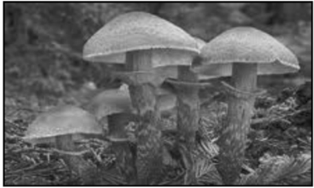 …………………………..
…………………………………………………………………………………………………………………….
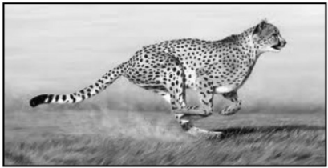 …………………………...
…………………………………………………………………………………………………………………….
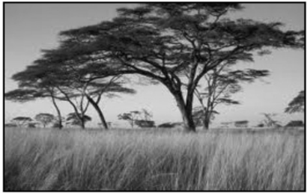 …………………………..
…………………………………………………………………………………………………………………….
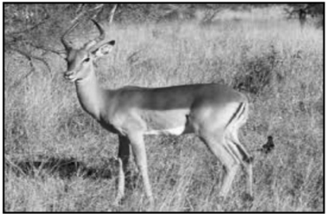 ……………………………
…………………………………………………………………………………………………………………….

3. The pedigree chart below illustrates the inheritance of muscle dystrophy in a given family.
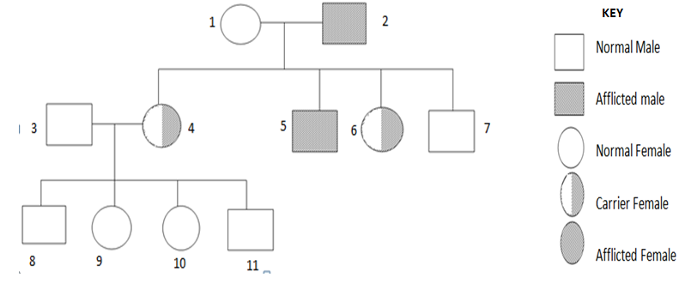
a) Suggest the possible genotypes of individual 2 and 4.Use the letter D to represent the gene for normal muscle formation. (2 marks)
………………………………………………………………………………………………………………………………………………………………………………………………………………………………………………………………………
(b) Explain why there are no male carriers (2 marks)
………………………………………………………………………………………………………………………………………………………………………………………………………………………………………………………………………………………………………………………………………………………………
(c) Work out the genotypes of the offspring’s from individual number 4 and an
inflicted male. (4 marks)

4. The figure 1 below represents a pea seed split open to show its structure. Figure 2
represents the same seedling 5 days after germination.
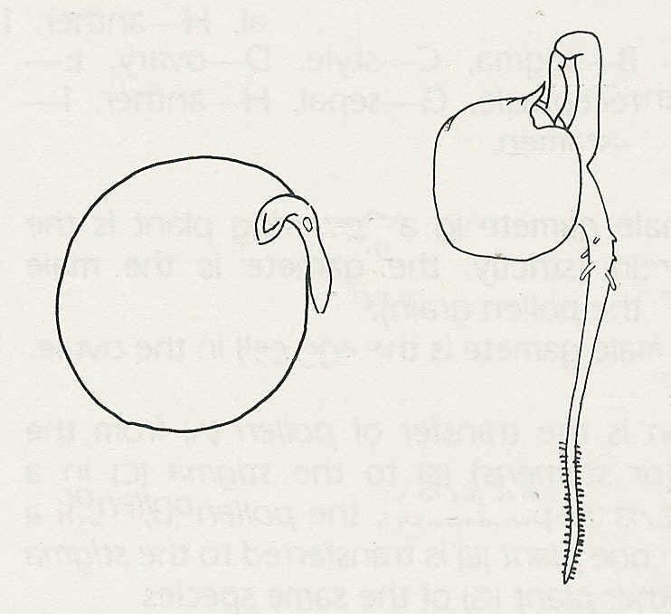
C
A
B
E
F
G
D

Fig 1
Fig 2

- Name the A, C and G. (3 marks)
A: ………………………………………………………………………………......
C: ……………………………………………G:…………………………………..
- State the functions of parts D and E. (2 marks)
D: …………………………………………………………………………………..
E: …………………………………………………………………………………..

- Give two differences between B and F. (2 marks)
………………………………………………………………………………………………………………………………………………………………………………………………………………………………………………………………………

- The early stages of germination take place in the soil where there is little or no
light for photosynthesis. How does the seedling obtain materials for its growth and energy needs during this time? (1 mark)
………………………………………………………………………………………………………………………………………………………………………………………………………………………………………………………………………………………………………………………………………………………………
5. (a) Shown below are the partial pressures (P) of oxygen and carbon (IV) oxide in two
regions A and B
A |  | B
PO₂ 160.00mmHg |  | PO₂ 40mmHg
PCO₂ 0.23mmHg |  | PCO₂ 45mmHg
- Using an arrow in each case, indicate the direction of movement of (i)
oxygen and (ii) carbon (IV) oxide (2 marks)

- Which region(s) of the mammalian body are represented by A and B?

A ……………………………………………………………… (1 mark)

B ……………………………………………………………… (1 mark)

- Shown below is the diagram of mechanical model used to demonstrate the
process of breathing in man

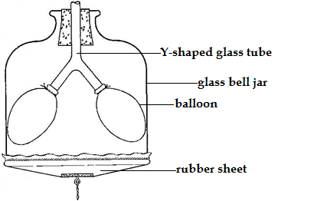

- Name the organ represented by the rubber sheet (1 mark)
………………………………………………………………………………………………………………………………………………………………

- Identify the phase of breathing represented in the model
(1 mark)
………………………………………………………………………………………………………………………………………………………………………………

- State two limitation of this model as a representation of the respiratory
apparatus of man (2 marks)

………………………………………………………………………………………………………………………………………………………………………………………………………………………………………………………………………………………………………………………………………………………………
SECTION B (40 MARKS)
Answer question 6(compulsory) and either question 7 or 8 in the spaces provided after question 8
6. The graph below shows the concentration of carbon (iv) oxide in a tropical rain forest that was measured during a period of 24 hours, from midnight. Study it carefully and then answer the questions that follow:

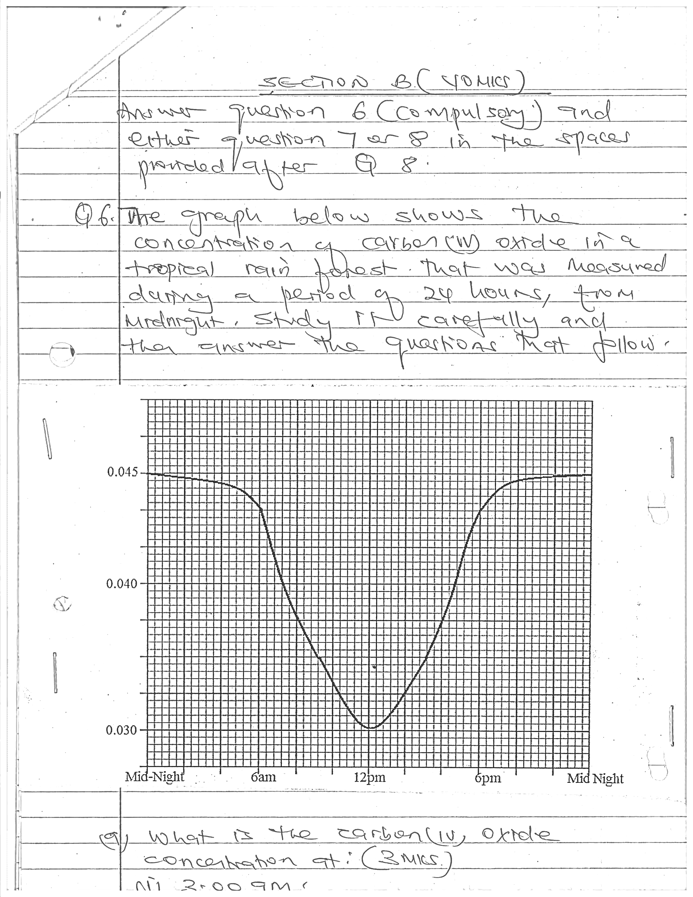

- What is the carbon(iv)oxide concentration at: (3 marks)
- 3.00am
................................................................................................................................................................................................................................................

- 12.00p.m.
................................................................................................................................................................................................................................................
- 4.00p.m.
................................................................................................................................................................................................................................................

- Describe the trend of the curve represented by the graph (3 marks)
................................................................................................................................................................................................................................................................................................................................................................................................................................................................................................................................
- Account for the carbon(iv) oxide concentration between:
- 6.00a.m. and 1.00p.m. (2 marks)
................................................................................................................................................................................................................................................
................................................................................................................................................................................................................................................
- 6.00a.m. and midnight (2 marks)
................................................................................................................................................................................................................................................
................................................................................................................................................................................................................................................

- Give a word equation for the process that utilizes carbon(iv) oxide in the forest (1 mark)
........................................................................................................................................................................................................................................................................
- Beside light, name four other environmental factors that would affect concentration of carbon (iv) oxide in the forest. (4 marks)
........................................................................................................................................................................................................................................................................
........................................................................................................................................................................................................................................................................
- What would happen if all trees were cut down? (3 marks)
................................................................................................................................................................................................................................................................................................................................................................................................................................................................................................................................................
- Write a word equation for the process that generates carbon(iv) oxide in the body
(1 mark)
........................................................................................................................................................................................................................................................................

- a) What is pollution (1 mark)
- Give examples of pollutants that can cause
- Air pollution (3 marks)
- Soil pollution (3 marks)
- Water pollution (3 marks)

- Using specific examples, outline the effects of environmental pollution. (10 marks)

8. (a) Define the term natural selection with reference to evolution. (2 marks)
(b) Describe how natural selection brings about adaptation of species to its
environment. (18 marks)

........................................................................................................................................................................................................................................................................
........................................................................................................................................................................................................................................................................
........................................................................................................................................................................................................................................................................
........................................................................................................................................................................................................................................................................
........................................................................................................................................................................................................................................................................
........................................................................................................................................................................................................................................................................
........................................................................................................................................................................................................................................................................
........................................................................................................................................................................................................................................................................
........................................................................................................................................................................................................................................................................
........................................................................................................................................................................................................................................................................
........................................................................................................................................................................................................................................................................
........................................................................................................................................................................................................................................................................
........................................................................................................................................................................................................................................................................
........................................................................................................................................................................................................................................................................
........................................................................................................................................................................................................................................................................
........................................................................................................................................................................................................................................................................
........................................................................................................................................................................................................................................................................
........................................................................................................................................................................................................................................................................

