ENKORIKA SEC. SCHOOL
Kenya Certificate of Secondary Education

MOCKS

231/1 BIOLOGY Paper 1

JULY 2022 – TIME: 2 Hours

Name: ………………………………………….....…… Adm No: ……….……

Class: ………………Candidate’s Signature: ………... Date: …..…/07/2022

INSTRUCTIONS TO CANDIDATES
1. Write your name and Admn. No. in the spaces above
2. Sign and write the date of examination in the space provided above.
3. This paper consists of 11 printed pages.
4. Candidates should check the question paper to ascertain that all the pages are printed as indicated and no questions are missing
5. Answer all the questions

FOR EXAMINER’S USE ONLY
Question | Maximum Score | Candidate’s Score
1-33 | 80

1. How does the study of biology help human beings in their day to day life? (2 marks)
………………………………………………………………………………………………………………………………………………………………………………………………………………………………………………………………………………………………………………………………………………………………………………………………

2. State one pre-caution that should be taken when placing a microscope on the table for
use. (1 mark)
………………………………………………………………………………………………………………………………………………………………………………………………
3. Below is a diagram of a human sperm cell.

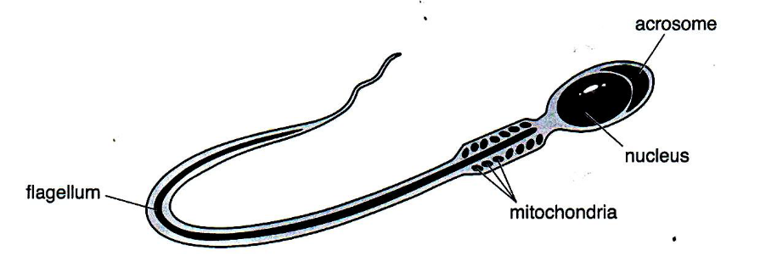

- Write the formula that would be used to calculate the magnification of the diagram. ( 1 mark)
………………………………………………………………………………………………………………………………………………………………………………

- The actual length of the sperm cell is 0.055m. Convert this value to micrometers (µm) ( 1 mark)
………………………………………………………………………………………………………………………………………………………………………………

4. State the sensory structure in the members of the class arachnida (1 mark)
………………………………………………………………………………………………………………………………………………………………………………………………………………………………………………………………………………………………

5. Name three classes of animals that excrete their nitrogenous wastes products mainly in form of uric acid compared to urea, (3 marks)
………………………………………………………………………………………………………………………………………………………………………………………………………………………………………………………………………………………………………………………………………………………………………………………………
6. Illustrated below is the movement of material in a certain physiological process

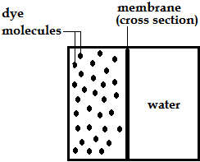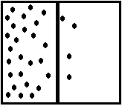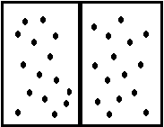

- (i) Name the physiological process illustrated above (1 mark)
………………………………………………………………………………………………………………………………………………………………
(ii) Give two examples of applicability of the process named in (a)(i)
above in plants . (2 marks)
…………………………………………………………………………………………………………………….…………………………………………………………………………………………………………………….…………………………………………………………………………
- State two ways by which the movement of the dye molecules would be slowed
down. (2 marks)
…………………………………………………………………………………………………………………….…………………………………………………………………………………………………………………….…………………………………………………………………………………………………………………….………………………………………………………………………………………
7. State the physiological changes that would occur in the following structures if the
environmental temperature was raised gradually from 22⁰ C to 40⁰ C (2 marks)

Sweat glands…………………………………………………………................................
…………………………………………………………………………………………….
Blood capillaries ………………………………………………………………………………………………………………………………………………………………………………………….

8. Suggest two ways in which the heartbeat changes when a person exercises. (2 marks)
………………………………………………………………………………………………………………………………………………………………………………………………………………………………………………………………………………………
9. The coronary artery supplies blood to the heart tissue. People with coronary thrombosis are unable to do much exercise. State the cause of coronary thrombosis and explain why people with this disorder are unable to do much exercise (2 marks)

………………………………………………………………………………………………………………………………………………………………………………………………………………………………………………………………………………………
……………………………………………………………………………………………
10. Explain the mechanism that increases blood flow through the skin. (3 marks)
………………………………………………………………………………………………………………………………………………………………………………………………………………………………………………………………………………………………………………………………………………………………………………………………

11. Two functions carried out by the Kidney are excretion and osmoregulation. Explain what is meant by each of these terms. (2 marks)

………………………………………………………………………………………………………………………………………………………………………………………………………………………………………………………………………………………………………………………………………………………………………………………………

12. Illustrated in the diagrams below is the position of chloroplasts (shown as dark structures, ) in a tropical plant species, at two different times of the day

I II
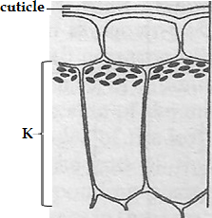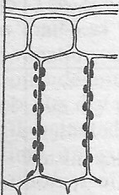
At 6am At 2pm

- Identify the tissue labelled K (1 mark)
………………………………………………………………………………………………………………………………………………………………………………
- Name the response shown by the chloroplasts in diagram I (1 mark)

………………………………………………………………………………………………………………………………………………………………………………

- Outline the importance of the orientation of the chloroplasts as illustrated in
diagram II . (2 marks)
…………………………………………………………………………………………………………………….…………………………………………………………………………………………………………………….…………………………………………………………………………………………………………………….
13. Give three reasons as to why biological control is preferred to chemical control in the control of pests and parasites (3 marks)
…………………………………………………………………………………………………………………………………………………………………………………………………………………………………………………………………………………………........................................................................................................................................................................................................................................................................................................
14. (a) Explain why an asthmatic patient produce a wheezing sound during breathing ?
(1 mark)
…………………………………………………………………………………………....................................................................................................................................................................................................................................................................
(b) What is the significance of the cartilage found in the human trachea being incomplete (c- shaped rings) (1 mark)
…………………………………………………………………………………………....................................................................................................................................................................................................................................................................
15. Proteins are said to be amphoteric; state the importance of this property. (1 mark)
………………………………………………………………………………………………………………………………………………………………………………………………………………………………………………………………………………………………
16. State two ways in which the lungs are adapted and explain how each adaptation improves
gas exchange (2 marks)
………………………………………………………………………………………………………………………………………………………………………………………………………………………………………………………………………………………………

17. State one role of the thick adipose tissue in aquatic mammals. (1 mark)
………………………………………………………………………………………………………………………………………………………………………………………………………………………………………………………………………………………………

18. State three adaptive characteristics of tapeworms to parasitic mode of life. (3 marks)
………………………………………………………………………………………………………………………………………………………………………………………………………………………………………………………………………………………………………………………………………………………………………………………………

19. The table below shows a summary of respiration.
Glucose
(i)
Pyruvic acid

Anaerobic respiration Anaerobic respiration
(ii) in plants in plants.

CO2 + H2O +ATP X + ATP Y + CO2 + ATP

(a) Name the process labelled (i) and (ii) in the diagram above. (2 marks)
(i)……………………………………………………………………………………

(ii)…………………………………………………………………………………...

(b) Name products X and Y. (2 marks)
………………………………………………………………………………………………………………………………………………………………………………………………………………………………………………………………………

20. State two reasons why the stomach lining is not usually digested by pepsin though it is
made of protein. (2marks)
………………………………………………………………………………………………………………………………………………………………………………………………………………………………………………………………………………………………

21. Explain why digestion must take place before absorption can occur. (3 marks)
………………………………………………………………………………………………………………………………………………………………………………………………………………………………………………………………………………………………
………………………………………………………………………………………………………………………………………………………………………………………………

22. Describe how oxygen in the alveolus reaches the red blood cells (2marks)
………………………………………………………………………………………………………………………………………………………………………………………………………………………………………………………………………………………………
………………………………………………………………………………………………
23. The warning below is found on the side of on the side of a cigarette.

SMOKING SERIOUSLY DAMAGES YOU HEALTH AND THE HEALTH OF THOSE AROUND YOU.

Describe ways in which smoking can damage your health and the health of those around you. (3 marks)
………………………………………………………………………………………………………………………………………………………………………………………………………………………………………………………………………………………………………………………………………………………………………………………………
24. Humans show variation in blood groups controlled by a single gene that has alleles A, B and O. The possible alleles for each blood group is shown in the table below.

Blood group | Possible genotypes
A | AA AO
B | BB BO
AB | AB
O | OO

- One of the alleles is recessive to the other two. Which is the recessive allele. Give a
reason for your answer. (2 marks)
………………………………………………………………………………………………………………………………………………………………………………………………………………………………………………………………………

- Which of the two alleles show co dominance. Give a reason for your answer. (2 marks)
……………………………………………………………………………………………………………………………………………………………………………………………………………………………………………………………………………….
25. The figure below is a diagram of the human female reproductive system.
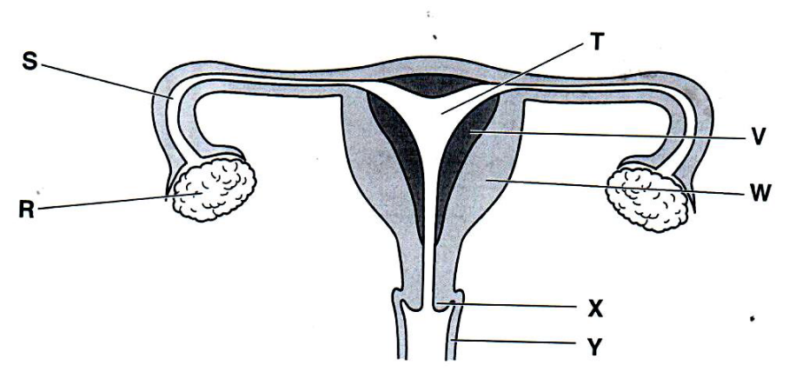
Complete the table below by stating the letter from the above figure that identifies the structure where each process occurs. (3 marks)

Process | Letter from figure above
Meiosis
Fertilization
Implantation

26. Mention two developmental changes that takes place in the ovary of a flower after fertilization. (2 marks)
………………………………………………………………………………………………………………………………………………………………………………………………………………………………………………………………………………………………………………………………………………………………………………………………………………………………………………………………………………………………

27. The figure below shows the fruiting body of a dandelion plant and a single fruit. The
fruiting body is made of many single fruits.

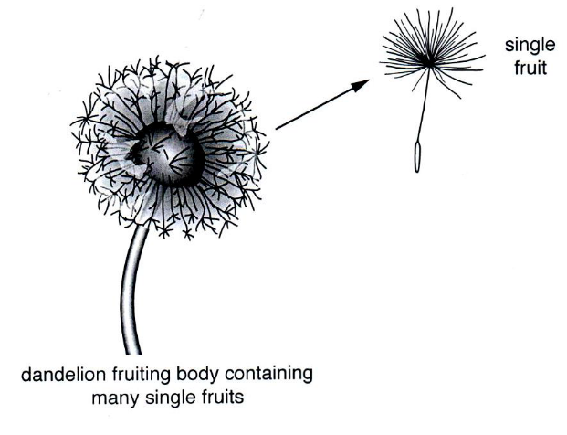

Suggest how the single dandelion fruits are dispersed from the parent plant. Give
a reason for your answer. (2 marks)

………………………………………………………………………………………………………………………………………………………………………………………………………………………………………………………………………………

28. Why does a seed increase in weight at the beginning of germination and then decrease in weight for a time once germination is underway? (2 marks)
………………………………………………………………………………………………………………………………………………………………………………………………………………………………………………………………………………………………………………………………………………………………………………………………
29. State two adverse effects skin lightening cosmetics may have on the skin. (2 marks)
………………………………………………………………………………………………………………………………………………………………………………………………………………………………………………………………………………………………………………………………………………………………………………………………

30. Identify three evolutionary characteristics in humans that make them superior organisms.
(3 marks)
………………………………………………………………………………………………………………………………………………………………………………………………………………………………………………………………………………………………………………………………………………………………………………………………
31. State three applications of genetics in Medicine. (3 marks)
………………………………………………………………………………………………………………………………………………………………………………………………………………………………………………………………………………………………………………………………………………………………………………………………………………………………………………………………………………………………………………………………………………………………………………………………
32. (a) Define cell specialization. (1 mark)
………………………………………………………………………………………………………………………………………………………………………………
(b) What is the role centrioles in cell division? (1 mark)
………………………………………………………………………………………………………………………………………………………………………………
………………………………………………………………………………………
33. Name two substances that are excreted through diffusion process in plants. (2 marks)
………………………………………………………………………………………………………………………………………………………………………………………………………………………………………………………………………………………………

This is the last printed page

