ENKORIKA SEC. SCHOOL
Kenya Certificate of Secondary Education

443/1 - AGRICULTURE - Paper 2
(THEORY)

Name……………………………………Index No…………. Adm. No……………

Candidates Signature………………………Class……………..Date……../7/2022

Instructions to students

(a) Write your name and index number in the spaces provided at the top of this page.
(b) Sign and write the date of the examination in the spaces provided.
(c) This paper consists of three sections: A, B and C.
(d) Answer all questions in sections A and B.
(e) Answer any two questions in section C.
(f) All answers should be written in the spaces provided.
(h) This paper consists of 13 pages.
(g) Candidate should check the question paper to ascertain that all pages are printed as indicated and that no questions are missing.
(i) Candidate should answer the questions in English.
j) The photographs must be coloured.

For Examiner’s Use Only

SECTION | QUESTIONS | MAXIMUM SCORE | CANDIDATES SCORE
A | 1 − 17 | 30
B | 18 − 21 | 20
C | 22 - 24 | 20
C |  | 20
 | TOTAL SCORE | 90

SECTION A (30 MARKS)
Answer all questions in this section in the spaces provided.

1. State four reasons for maintaining farm tools. (2 Marks)
………………………………………………………………………………………………………………………………………………………………………………………………………………………………………………………………………………………………………………………………………………………………………………………………………………………………………………………………………………………………
2. Outline four causes of high mortality rate in lambs. (2 Marks)
………………………………………………………………………………………………………………………………………………………………………………………………………………………………………………………………………………………………………………………………………………………………………………………………
3. State three limitations of human power as a source of power in the farm. (1½ Marks)
………………………………………………………………………………………………………………………………………………………………………………………………………………………………………………………………………………………………………………………………………………………………………………………………
4. Give three qualities of colostrum which makes it suitable for breeding newly born causes. (1 ½ Marks)

………………………………………………………………………………………………………………………………………………………………………………………………………………………………………………………………………………………………………………………………………………………………………………………………

5. Outline four disadvantages that may arise from inbreeding in livestock production. (2 Marks)
………………………………………………………………………………………………………………………………………………………………………………………………………………………………………………………………………………………………………………………………………………………………………………………………
6. State three ways of extracting honey from honey combs. (1 ½ Marks)
………………………………………………………………………………………………………………………………………………………………………………………………………………………………………………………………………………………………………………………………………………………………………………………………
7. Name the causal organism of contagious abortion. (1 Mark)
………………………………………………………………………………………………………………………………………………………………………………………………………………………………………………………………………………………………
8. Outline four methods that may be used to improve milk production in a herd of indigenous cattle. (2 Marks)
………………………………………………………………………………………………………………………………………………………………………………………………………………………………………………………………………………………………………………………………………………………………………………………………
9. State three functions of lubrication system in a tractor engine. (1 ½ Marks)
………………………………………………………………………………………………………………………………………………………………………………………………………………………………………………………………………………………………………………………………………………………………………………………………
10. Give three signs of broodness in poultry. (1 ½ Marks)
………………………………………………………………………………………………………………………………………………………………………………………………………………………………………………………………………………………………………………………………………………………………………………………………
11. State four importance of vitamins in livestock nutrition. (2 Marks)
………………………………………………………………………………………………………………………………………………………………………………………………………………………………………………………………………………………………………………………………………………………………………………………………
12. Distinguish between isolation and quarantine as used in livestock management. (1 Mark)
………………………………………………………………………………………………………………………………………………………………………………………………………………………………………………………………………………………………………………………………………………………………………………………………
13. Give the functions of the following parts in poultry digestive system:
i). Gizzard (1 Mark)
………………………………………………………………………………………………………………………………………………………………………………………………………………………………………………………………………
ii). Caecum (1 Mark)
………………………………………………………………………………………………………………………………………………………………………………………………………………………………………………………………………
14. Name three sections found in a furrowing pen. (1 ½ Marks)
………………………………………………………………………………………………………………………………………………………………………………………………………………………………………………………………………………………………………………………………………………………………………………………………
15. Outline six advantages of live fences. (3 Marks)
………………………………………………………………………………………………………………………………………………………………………………………………………………………………………………………………………………………………………………………………………………………………………………………………
16. State four requirements of a brooder. (2 Marks)
………………………………………………………………………………………………………………………………………………………………………………………………………………………………………………………………………………………………………………………………………………………………………………………………
17. Outline signs of good health under the following-:
i) Movement (1 mark)
………………………………………………………………………………………………………………………………………………………………………………
ii) Urine (1 mark)
……………………………………………………………………………………………………………………………………………………………………………....
iii) Posture (1 mark)
………………………………………………………………………………………………………….. ………………………………………………………………….

SECTION B (20 MARKS)

18. Study the diagrams below then answer the questions that follow


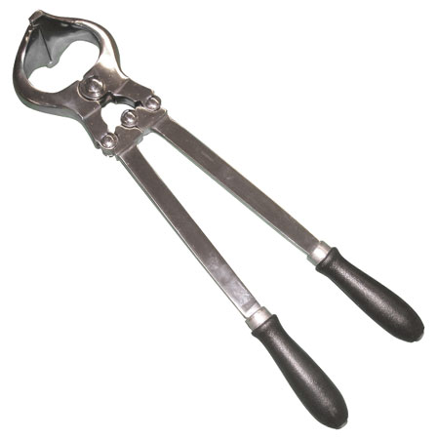
R
S

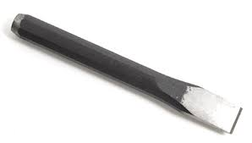
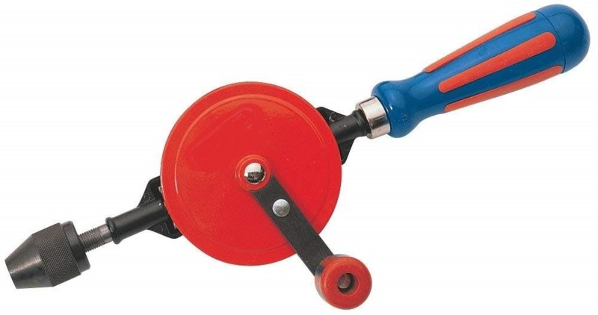
Speed gear
Chuck
Crank and handler

T
U

- Identify each of the farm tool/equipment illustrated above
R .....................................................................................................................(½ mark)

S ..................................................................................................................... .(½ mark)

T.......................................................................................................................(½ mark)

U .......................................................................................................................(½ mark)
- State the use of tool equipment labeled R and U.

R …………………………………………………………………....................(1 mark)

U ....................................................................................................................... (1 mark)

(c) Give two maintenance practices of tool labeled S (2 marks)
............................................................................................................................................................................................................................................................................................................................................................................................................................................................................................................................................................................

19. The diagram below illustrates a farm structure. Study it carefully and answer the questions that follow.

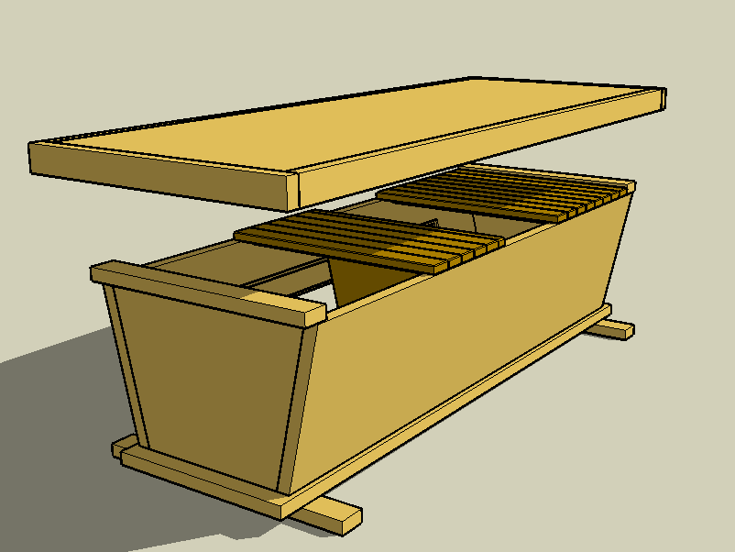

i) Identify the structure (½ mark)
........................................................................................................................................................................................................................................................................
ii) State two advantages of the above structure (1mark)
............................................................................................................................................................................................................................................................................................................................................................................................................

iii) State three maintenance practices carried out on the structure (3 marks)
................................................................................................................................................................................................................................................................................................................................................................................................................................................................................................................................................

20. Below is a photograph showing a process carried in the farm. Study it and answer
the questions that follow.

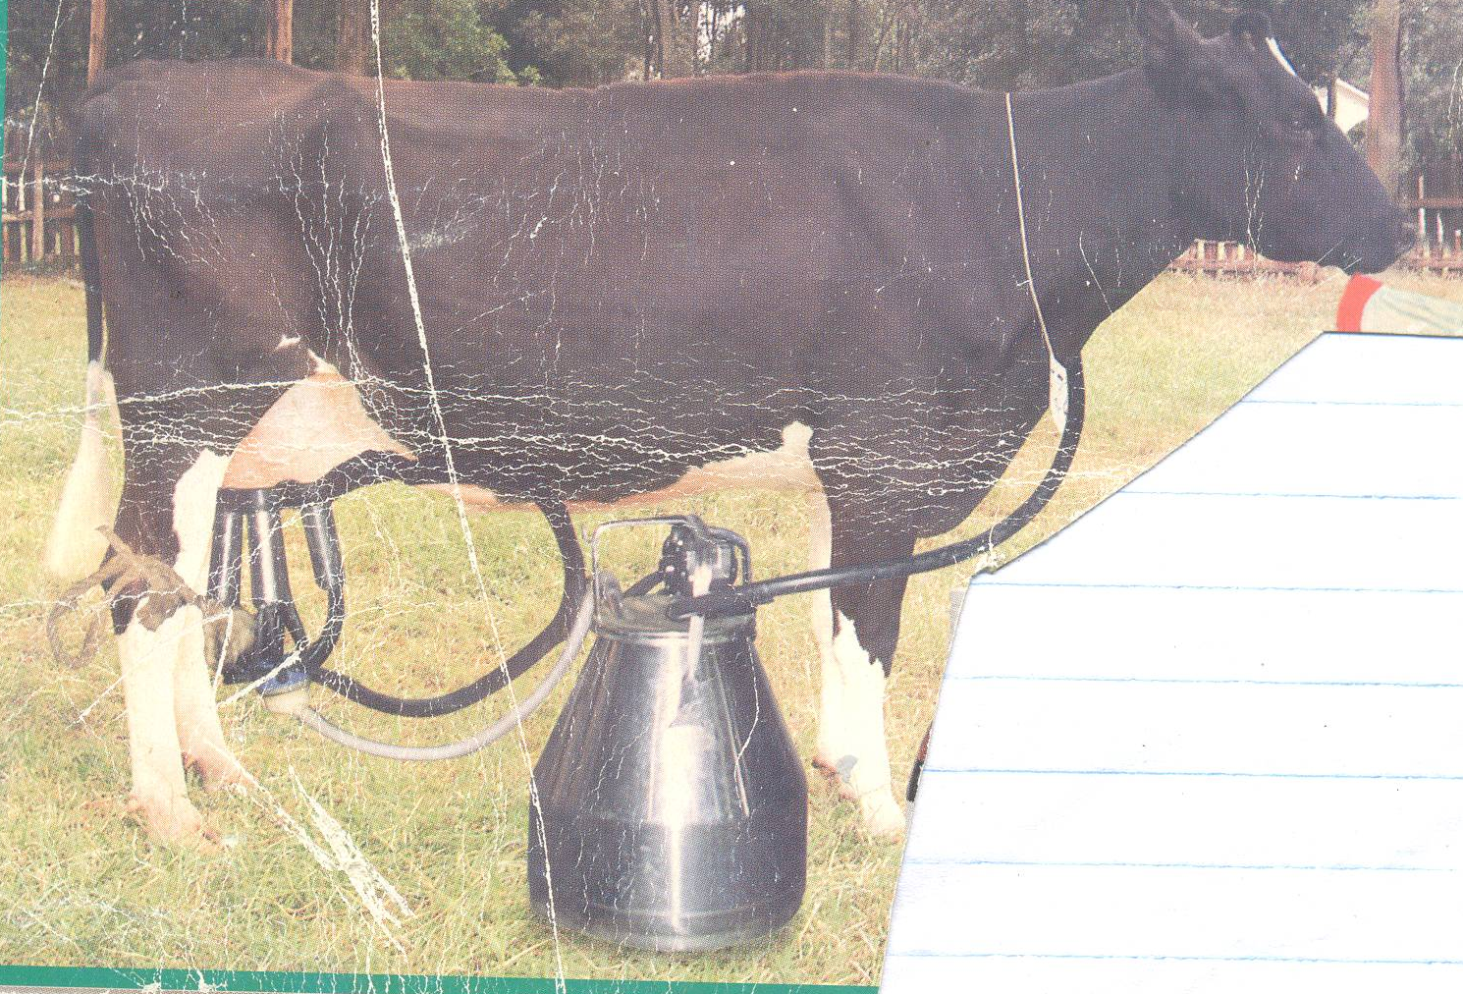

(a) Name the practice illustrated in the photograph. (1 mark)
........................................................................................................................................................................................................................................................................
(b) State two advantages of the method above over its alternative method. (2 marks)
........................................................................................................................................................................................................................................................................................................................................................................................................................................................................................................................................

(c) Observing the photograph above, mention any three visible external
characteristics that make it ideal for dairy. (3 marks)
....................................................................................................................................................................................................................................................................................................................................................................................................................................................................................................................................................................................................................................................................................

21. The diagram below illustrate one of the systems of a tractor. Study it carefully
and answer the questions that follows.
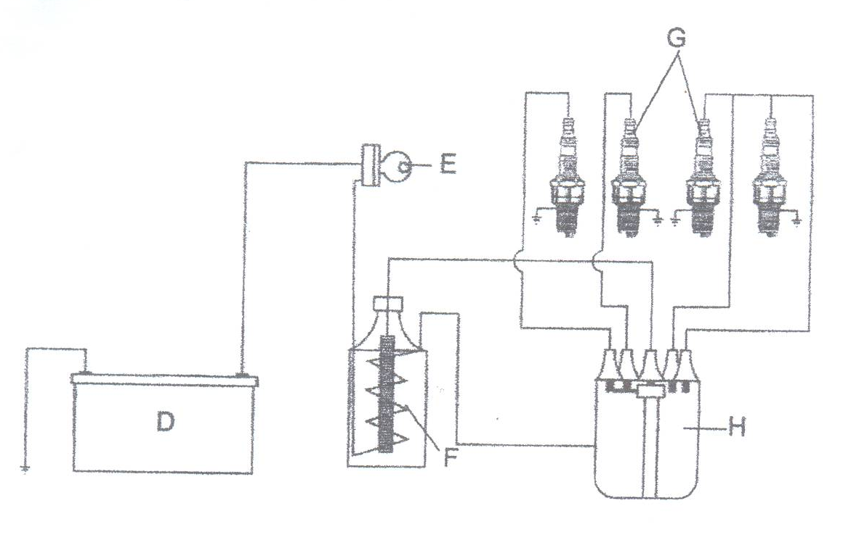

(a) Identify the system of a tractor represented by the diagram above. ( ½ mark)
............................................................................................................................................................................................................................................................................................................................................................................................................
(b) Name the parts of the system labeled D, E, and H. (1 ½ marks)
D ……………………………………………………………………………………
E ……………………………………………………………………………………
H…………………………………………………………………………………….

(c) Give one function of each of the parts labeled F, G and H. (3 marks)
F ………………………………………………………………………………………………………………………………………………………………………………
G
………………………………………………………………………………………………………………………………………………………………………………
H
………………………………………………………………………………………………………………………………………………………………………………

SECTION C (40 MARKS)
Answer any two questions

22. (a) Explain eight functions you can carry out in a crush. (8 marks)
(b) Describe six advantages of rotational grazing. (6 marks)
(c) Describe six effects of parasites on livestock. (6 marks)

23. (a) Describe fish farming under the following
- Sitting fish pond (5 marks)
- Feeding (5 marks)
(b) Outline five advantages of artificial insemination in cattle management. (5 marks)
(c) Explain five functions of water in animal nutrition (5 marks)

24. (a) Discuss the life cycle of a three host tick (8 marks)
(b) Discuss any four factors that may influence power output of a drought animal. (4 marks)
(c) Discuss milk fever under the following headings
(i) Cause (1 mark)
(ii) Symptoms of attack (5 marks)
- Control (2 marks)

………………………………………………………………………………………………………………………………………………………………………………………………………………………………………………………………………………………………………………………………………………………………………………………………………………………………………………………………………………………………………………………………………………………………………………………………………………………………………………………………………………………………………………………………………………………………………………………………………………………………………………………………………………………………………………………………………………………………………………………………………………………………………………………………………………………………………………………………………………………………………………………………………………………………………………………………………………………………………………………………………………………………………………………………………………………………………………………………………………………………………………………………………………………………………………………………………………………………………………………………………………………………………………………………………………………………………………………………………………………………………………………………………………………………………………………………………………………………………………………………………………………………………………………………………………………………………………………………………………………………………………………………………………………………………………………………………………………………………………………………………………………………………………………………………………………………………………………………………………………………………………………………………………………………………………………………………………………………………………………………………………………………………………………………………………………………………………………………………………………………………………………………………………………………………………………………………………………………………………………………………………………………………………………………………………………………………………………………………………………………………………………………………………………………………………………………………………………………………………………………………………………………………………………………………………………………………………………………………………………………………………………………………………………………………………………………………………………………………………………………………………………………………………………………………………………………………………………………………………………………………………………………………………………………………………………………………………………………………………………………………………………………………………………………………………………………………………………………………………………………………………………………………………………………………………………………………………………………………………………………………………………………………………………………………………………………………………………………………………………………………………………………………………………………………………………………………………………………………………………………………………………………………………………………………………………………………………………………………………………………………………………………………………………………………………………………………………………………………………………………………………………………………………………………………………………………………………………………………………………………………………………………………………………………………………………………………………………………………………………………………………………………………………………………………………………………………………………………………………………………………………………………………………………………………………………………………………………………………………………………………………………………………………………………………………………………………………………………………………………………………………………………………………………………………………………………………………………………………………………………………………………………………………………………………………………………
This is the last printed page

