NAME………………………………………………………ADM NO…………CLASS………..
DATE………………SIGN.............………
443/1
AGRICULTURE
PAPER 1
SEPTEMBER 2022
MECS JOINT EXAMINATION

INSTRUCTIONS TO CANDIADATES
- Write your name, admission number and class
- This paper contains three sections
- Answer all question in section A and B
- In section C answer any two questions
- Candidates should check the question paper to ascertain that all pages are printed as indicated and that no questions are missing
- This paper has 10 printed pages
- Candidates must answer all the questions in English

For examiner’s use only
Section | Questions | Maximum score | Candidate score
A | 1 -16 | 30
B | 17 -20 | 20
C |  | 20
 |  | 20
Total score |  | 90

SECTION A 30 MARKS.ANSWER ALL QUESTION
1.Differentiate between olericulture and pomoculture as used in crop production. (1mark)
……………………………………………………………………………………………………………………………………………………………………………………………………………………………………………………………………………………
……………………………………………………………………………………………………………………………………………………………………………………………………………………………………………………………………………………
2.Give two methods of farming (1marks)
……………………………………………………………………………………………………………………………………………………………………………………………………………………………………………………………………………………
……………………………………………………………………………………………………………………………………………………………………………………………………………………………………………………………………………………
3.Give two examples for each of the following types of cost incurred in broiler production.
a)Variable cost (1 mark)
……………………………………………………………………………………………………………………………………………………………………………………………………………………………………………………………………………………
b)fixed cost (1 mark)
……………………………………………………………………………………………………………………………………………………………………………………………………………………………………………………………………………………
4.Give four advantages of crop rotation. (2marks)
……………………………………………………………………………………………………………………………………………………………………………………………………………………………………………………………………………………
……………………………………………………………………………………………………………………………………………………………………………………………………………………………………………………………………………………
5.State four factors to consider when choosing seed rate. (2marks)
……………………………………………………………………………………………………………………………………………………………………………………………………………………………………………………………………………………
……………………………………………………………………………………………………………………………………………………………………………………………………………………………………………………………………………………
6(a) Give four reasons for using certified seeds for planting. (2marks)
……………………………………………………………………………………………………………………………………………………………………………………………………………………………………………………………………………………
……………………………………………………………………………………………………………………………………………………………………………………………………………………………………………………………………………………
(b).Give four disadvantages of using non capped multiple stem pruning in coffee (2marks)
……………………………………………………………………………………………………………………………………………………………………………………………………………………………………………………………………………………
……………………………………………………………………………………………………………………………………………………………………………………………………………………………………………………………………………………
7. State two reasons why cassava should be grown as the last crop in crop rotation programme. (1mark)
……………………………………………………………………………………………………………………………………………………………………………………………………………………………………………………………………………………
8.State four importance of farm records. (2marks)
……………………………………………………………………………………………………………………………………………………………………………………………………………………………………………………………………………………
……………………………………………………………………………………………………………………………………………………………………………………………………………………………………………………………………………………
9.Name two aspects of light that affect crop production. (1mark)
……………………………………………………………………………………………………………………………………………………………………………………………………………………………………………………………………………………
……………………………………………………………………………………………………………………………………………………………………………………………………………………………………………………………………………………
10.(a) What is tissue culture? (1mark)
……………………………………………………………………………………………………………………………………………………………………………………………………………………………………………………………………………………
……………………………………………………………………………………………………………………………………………………………………………………………………………………………………………………………………………………
(b) State two importance of tissue culture in crop propagation. (1marks)
……………………………………………………………………………………………………………………………………………………………………………………………………………………………………………………………………………………
……………………………………………………………………………………………………………………………………………………………………………………………………………………………………………………………………………………
11.a) Apart from the identity of owner, title number and size of land, name other two essentials contained on a land title deed. (2marks)
……………………………………………………………………………………………………………………………………………………………………………………………………………………………………………………………………………………
……………………………………………………………………………………………………………………………………………………………………………………………………………………………………………………………………………………
b) Give four importance of a land title deed. (2marks)
……………………………………………………………………………………………………………………………………………………………………………………………………………………………………………………………………………………
……………………………………………………………………………………………………………………………………………………………………………………………………………………………………………………………………………………
12.List four methods of fertilizer application. ( 2marks)
……………………………………………………………………………………………………………………………………………………………………………………………………………………………………………………………………………………
……………………………………………………………………………………………………………………………………………………………………………………………………………………………………………………………………………………
13. State four advantages of growing maize in rows instead of broadcasting. (2marks)
……………………………………………………………………………………………………………………………………………………………………………………………………………………………………………………………………………………
…………………………………………………………………………………………………………………………………………………………………………………………………………………………………………………………………………………..
14. Name four factors that determine the choice of a nursery site. (2marks)
……………………………………………………………………………………………………………………………………………………………………………………………………………………………………………………………………………………
…………………………………………………………………………………………………………………………………………………………………………………………………………………………………………………………………………………..
15. Name two post-harvest practices in beans. (1marks)
……………………………………………………………………………………………………………………………………………………………………………………………………………………………………………………………………………………
…………………………………………………………………………………………………………………………………………………………………………………………………………………………………………………………………………………..
16. Give four reasons why burning is discouraged as a method of land clearing. (2marks)
……………………………………………………………………………………………………………………………………………………………………………………………………………………………………………………………………………………
…………………………………………………………………………………………………………………………………………………………………………………………………………………………………………………………………………………..
SECTION B 20 MARKS
17. The table below shows output of maize in response to increase in D.A.P fertilizers on one hectare of land.
Fixed input land (in ha) | Variable input D.A.P in 30kg-bag | Total product maize yield in 90-kg bag | Average product (AP) maize in 90kg bag | Marginal product (M.P) in 90kg bag
1  1  1  1  1 | 0  1  2  3  4 | 2  5  14  21  26 | -  -  -  -  - | -  -  -  -  -
a) Fill in the table for average product (A.P) and marginal products (M.P) 5marks
18. The diagram below shows a structure used in crop production.
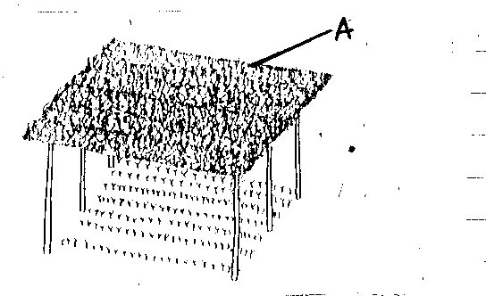

(a). Identify the structure above. (1mark)
…………………………………………………………………………………………………………………………………………
(b). Give a reason for carrying out each of the following practices in the structure shown above
(i).Pricking out. (1mark) ……………………………………………………………………………………………………………………………………………………………………………………………………………………………………………………………………………………
(ii). Hardening off. (1mark)
……………………………………………………………………………………………………………………………………………………………………………………………………………………………………………………………………………………
(c).State two importance of the part labelled A in the above structure. (2marks)
……………………………………………………………………………………………………………………………………………………………………………………………………………………………………………………………………………………
19.Form two student put some soil sample in a measuring cylinder, added some water and sodium carbonate and then covered the cylinder with the hand and shook the cylinder for about two minutes. He left the cylinder on the bench for one hour. The result was as shown below.
Floating organic matter
b

c

d

d
(i). Name the layers marked b,c, and d. (3marks)
b)……………………………………………………………………………………………………………………………………
c)…………………………………………………………………………………………………………………………………….
d)……………………………………………………………………………………………………………………………………
(ii). What was the function of sodium carbonate in this experiment? (Imark)
……………………………………………………………………………………………………………………………………………………………………………………………………………………………………………………………………………………
(iii). What was the aim of this experiment ? (lmark)
……………………………………………………………………………………………………………………………………………………………………………………………………………………………………………………………………………………

20. Study the diagram below and answer the questions that follow.

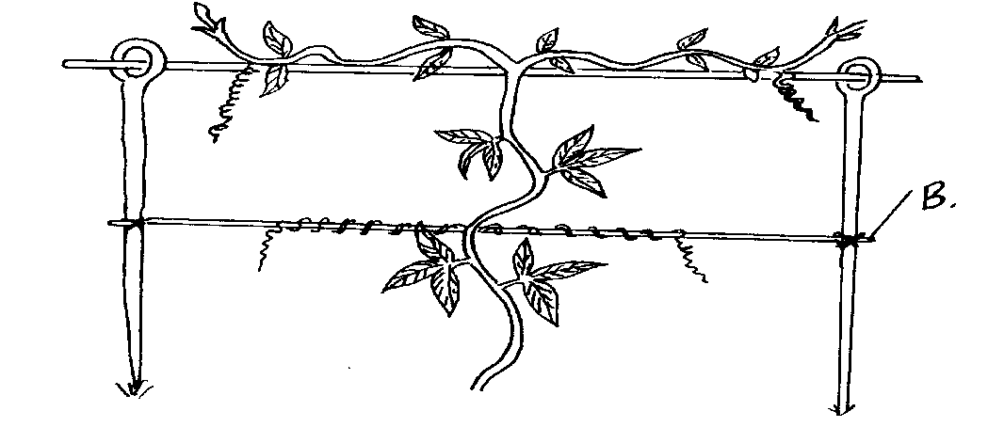

(a) Name the crop production practice illustrated above. (1mark)
……………………………………………………………………………………………………………………………………………………………………………………………………………………………………………………………………………………
b) Name a material that may be used as part B in the diagram (1mark)
……………………………………………………………………………………………………………………………………………………………………………………………………………………………………………………………………………………

c) State three reasons why the practice is done in crops. (3marks)

……………………………………………………………………………………………………………………………………………………………………………………………………………………………………………………………………………………
…………………………………………………………………………………………………………………………………………

SECTION C 40 MARKS( ANSWER ONLY TWO QUESTIONS)
21. (a) Outline any ten marketing functions (10marks)
(b) Discuss any five problems in marketing of agricultural produce (10marks)
22.Describe the production of tomatoes (Lycoperiscon esculentum) under the following subheadings.
(a) Ecological requirements (4marks)
(b) Nursery establishment (4marks)
(c) Transplanting (4marks)
(d) Seed bed preparation (4marks)
(e) Field management practices (4marks)
23a) Explain eight factors that encourage soil erosion. (8marks)
b) Describe seven management practices that should be carried out on a vegetable nursery after sowing until the seedlings are ready for transplanting. (7marks)
c) Describe the harvesting of sugarcane. (5marks)
………………………………………………………………………………………………………………………………………………………………………………………………………………………………………………………………………………………………………………………………………………………………………………………………………………………………………………………………………………………………………………………………………………………………………………………………………………………………………………………………………………………………………………………………………………………………………………………………………………………………………………………………………………………………………………………………………………………………………………………………………………………………………………………………………………………………………………………………………………………………………………………………………………………………………………………………………………………………………………………………………………………………………………………………………………………………………………………………………………………………………………………………………………………………………………………………………………………………………………………………………………………………………………………………………………………………………………………………………………………………………………………………………………………………………………………………………………………………………………………………………………………………………………………………………………………………………………………………………………………………………………………………………………………………………………………………………………………………………………………………………………………………………………………………………………………………………………………………………………………………………………………………………………………………………………………………………………………………………………………………………………………………………………………………………………………………………………………………………………………………………………………………………………………………………………………………………………………………………………………………………………………………………………………………………………………………………………………………………………………………………………………………………………………………………………………………………………………………………………………………………………………………………………………………………………………………………………………………………………………………………………………………………………………………………………………………………………………………………………………………………………………………………………………………………………………………………………………………………………………………………………………………………………………………………………………………………………………………………………………………………………………………………………………………………………………………………………………………………………………………………………………………………………………………………………………………………………………………………………………………………………………………………………………………………………………………………………………………………………………………………………………………………………………………………………………………………………………………………………………………………………………………………………………………………………………………………………………………………………………………………………………………………………………………………………………………………………………………………………………………………………………………………………………………………………………………………………………………………………………………………………………………………………………………………………………………………………………………………………………………………………………………………………………………………………………………………………………………………………………………………………………………………………………………………………………………………………………………………………………………………………………………………………………………………………………………………………………………………………………………………………………………………………………………………………………………………………………………………………………………………………………………………………………………………………………………………………………………………………………………………………………………………………………………………………………………………………………………………………………………………………………………………………………………………………………………………………………………………………………………………………………………………………………………………………………………………………………………………………………………………………………………………………………………………………………………………………………………………………………………………………………………………………………………………………………………………………………………………………………………………………………………………………………………………………………………………………………………………………………………………………………………………………………………………………………………………………………………………………………………………………………………………………………………………………………………………………………………………………………………………………………………………………………………………………………………………………………………………………………………………………………………………………………………………………………………………………………………………………………………………………………………………………………………………………………………………………………………………………………………………………………………………………………………………………………………………………………………………………………………………………………………………………………………………………………………………………………………………………………………………………………………………………………………………………………………………………………………………………………………………………………………………………………………………………………………………………………………………………………………………………………………………………………………………………………………………………………………………………………………………………………………………………………………………………………………………………………………………………………………………………………………………………………………………………………………………………………………………………………………………………………………………………………………………………………………………………………………………………………………………………………………………………………………………………………………………………………………………………………………………………………………………………………………………………………………………………………………………………………………………………………………………………………………………………………………………………………………………………………………………………………………………………………………………………………………………………………………………………………………………………………………………………………………………………………………………………………………………………………………………………………………………………………………………………………………………………………………………………………………………………………………………………………………………………………………………………………………………………………………………………………………………………………………………………………………………………………………………………………………………………………………………………………………………………………………………………………………………………………………………………………………………………………………………………………………………………………………………………………………………………………………………………………………………………………………………………………………………………………………………………………………………………………………………………………………………………………………………………………………………………………………………………………………………………………………………………………………………………………………………………………………………………………………………………………………………………………………………………………………………………………………

