MASTERED REVISION
PREDICTION ONE – JULY 2022
BIOLOGY PAPER 231/2
MARKING SCHEME

1. a) In hypotonic In hypertonic

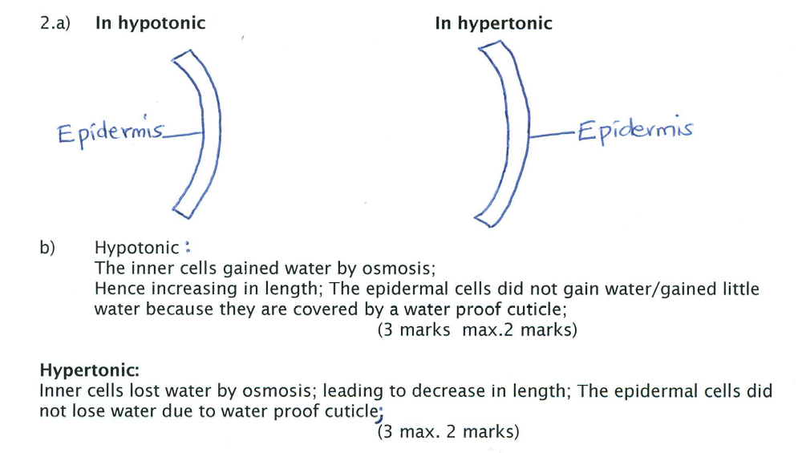
b) Hypotonic;
The inner; cells gained water by osmosis;
Hence increasing in length; The epidermal cells did not gain water/ gained little water because they are covered by a water proof cuticle;
(3 marks max 2 marks)

Hypertonic
Inner cells lost water by osmosis; leading to decrease in length; The epidermal cells did not lose water due to water proof cuticle;
(3 marks max 2 marks)
c) Support in herbaceous plant;
Absorption of water;
Opening and closing of stomata
Feeding in insectivores plants;
Movement of water from cell to cell;
( 2 marks ( mark 1st 2)

2. Part it plays Description of feeding method

Decomposer; Gets its energy from dead or waste matter;

Carnivore; Gets its energy by eating other animals;

Producer; Making organic nutrients using energy from sunlight;

Herbivore ; Gets its energy by eating plants;

3. a) Individual 2 - X^{d}Y
Individual 4 - X^{D}X^{d}
(b) Males have only one X – chromosomes; thus no chance of heterozygous state; since the gene is located on the non-homologous portions of the X-chromosome OWTTE
(c)
Parental Genotype: X^{D}X ^{d} × X ^{d} Y ;
Gametes : X^{D} X ^{d} X ^{d} Y ;
Fusion ;

Offspring X^{D}X^{d} X^{D}Y X^{d}X^{d} X^{d}Y ;
Genotypes:
Rej. If cross is not shown
If fusion lines penetrate the cell
If the cycle is not continuous

4. (a) A-Plumule; C: Cotyledon; G: Root hair;
(b) D: Carry out photosynthesis when exposed to light; E: Anchorage;
(c) B shorter than F; B has younger tissues than F; B usually found covered by coleorhizae,
which is lacking in F; [mark 1st 2]
(d) Enzymes digest stored food in the cotyledon, which is then transported in solution form by
phloem/translocation;

5. a) (i) PO₂ 160.00mmHg ; PO₂ 40mmHg
PCO₂ 0.23mmHg ; PCO₂ 45mmHg
(ii) A – Air in the lung alveolar cavity/ sac
B – Blood in the alveolar blood capillaries
b) i) - Diaphragm rej. Diaphram
ii) - Inhalation (since the balloons re inflated) / breathing in;
iii) Walls/ sides of the glass, bell jar, representing the rib cage/ chest cavity; ribs intercostal muscles are rigid/ immovable/ fixed whereas/ while the walls of the chest cavity can be moved upward, downwards, inwards, outwards by intercostal muscles. Acc. The rubber sheet is flat while the human diaphragm is dome-shaped/ Acc. The balloons are spherical/ oval while the mammalian lung is divided into lobes

SECTION B (40 MARKS)
6. (a) (i) 0.0425;
(ii) 0.0295;
- 0.0325;

- After midnight, the CO₂ concentration rises gradually until about 4.00a.m.; thereafter, the concentration falls rapidly reaching the minimum level at about 1.30p.m;
Then the CO₂ concentration increases gradually at first then rapidly reaching maximum levels at about midnight;
- As light intensity increases, do does the rate of photosynthesis which is accompanied by an increase in CO₂ uptake; this lowering its concentration in the surrounding air;
- A decrease in light intensity lowers the rate of photosynthesis; which lowers CO₂ utilization causing its gradual accumulation in the environment;
- Carbon + water light + energy glucose x oxygen;
- Chlorophyll
Oxide
- – Temperature;
- Availability of water;
- Mineral salts;
- Soil pH;

- Levels of CO₂ increase in the environment; while levels of O₂ fall; leading to global warming;
- Glucose + oxygen enzymes carbon + water + energy;
(iv) oxide
Score 1 mark for enzymes in between the arrow.

7. a) It is the release of substances into the environment in qualities that are harmful to
the environment / the living organisms;
b) i) Air Pollution – dust; smoke; carbon II oxide; sulphur (IV) oxide; chlorofluorocarbons;
lead;
- Soil pollution – Inorganic fertilizers; solid wastes; oil spills; and untreated industrial / effluents;
- Water Pollution – Untreated sewage; surface run-off; oil spills; pesticides / herbicides;

c) - Pollution cause respiratory irritation and diseases such as asthma for example dust,
sulphur (IV) oxide and chlorine gas;
- Spread of water borne diseases such as cholera, typhoid; from untreated sewerage or surface run-off;
- Poisoning from water contaminated with industrial effluents, pesticides and herbicides;
- Corrosion of building and roofs by acid rain from gases as chlorine and nitrogen(IV) oxide;
- Death of aquatic life; due to increased oxygen demand or suffocation from oil spills, decomposition of organic matter and organic fertilizers, suffocation and death of human beings and other mammals; from smoke or carbon(II) oxide;
- Reduced primary productivity in the ecosystem; due to stomata by dust or other particulate matter;
- Brain damage in young children; due to lead poisoning from exhaust fumes from cars;
- Global warming; due to accumulation of carbon (IV) oxide that comes from burning processes and deforestation;
- Depletion of ozone layer; leading to increased penetration of ultra-violet light that affects crops and causes skin cancer and eye cataracts;
(14 points, max 10 marks)

8. a) Nature selects those individuals/ organisms that are well adopted/ sufficient; and allow them to
survive and breed and rejects those that are poorly adopted by causing them to perish;
b) - Individuals of the same species show certain variation; that are caused by gene mutations;
- The variations can be passed from parents to offspring; through genetic inheritance;
- Organisms generally produce more offsprings than the environment can support; hence
there is always a struggle for existence; due to competition among individuals for scarce resources.
- Individuals posess traits / characteristics that enable them to have competitive advantage
to survive in the struggle; in the end the well adopted/ suited individuals survive; and reach productive age; and pass over their favourable traits to their offspring; since survival is for the fittest;
- Poorly adopted individuals/ those without favourable traits/ perish/die; and fail to reach
sexual maturity/ reproductive age; hence do not pass their traits to their offspring; the fittest individual only survive;
- After many generations there is accumulation of favourable genes/ traits; well suited to
the environment.
- The fittest/ well - adapted survive

